**Use logo in adobeforms**

1. Go to Tcode SFP .Create an interface and then create a form(For details ,please refer the previous demo)

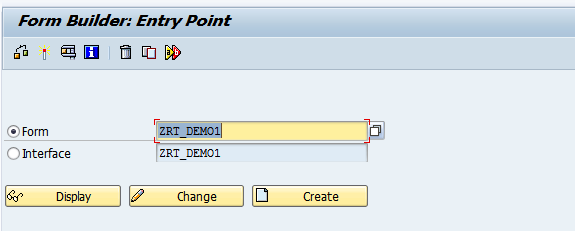

1. Click on Layout.

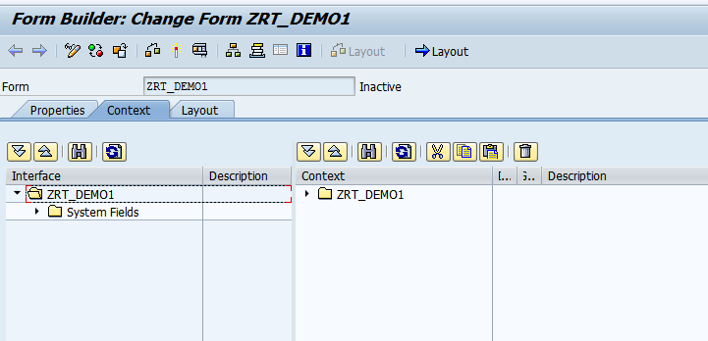

1. Drag and drop the Image icon from the object Library to the Design view. 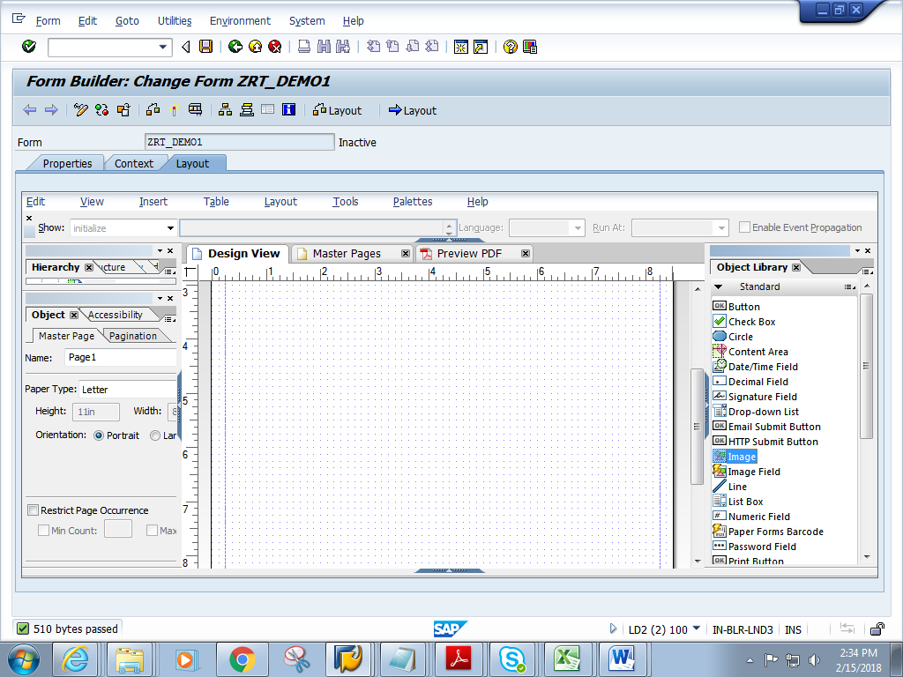
2. Double click on the image. In the object window, click on the folder icon .

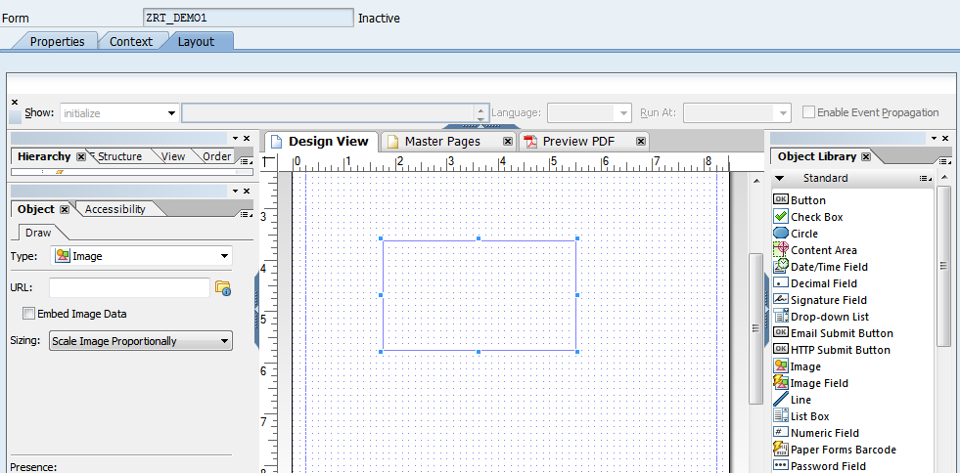

5) Choose the image saved on your local machine. The URL gets populated.

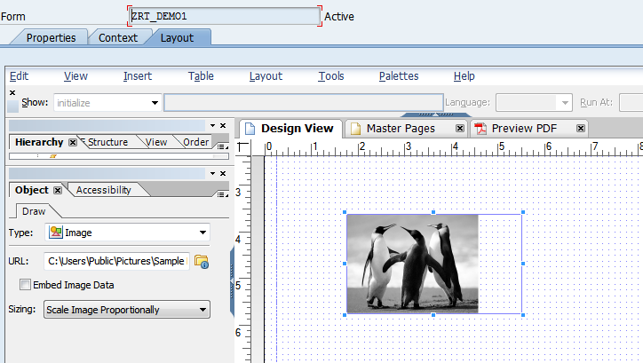

6)Check the embed data check box

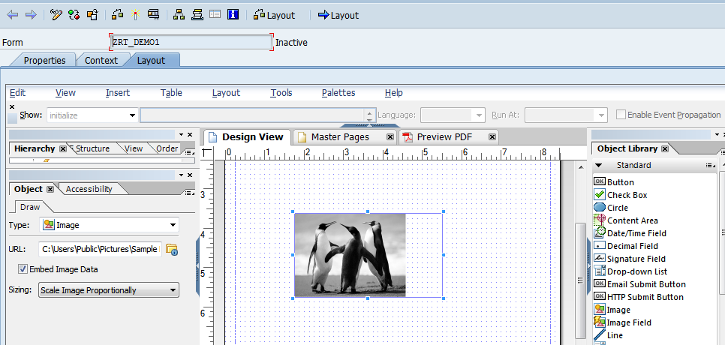

7) Click on context. Save and activate the form.

8) Execute the form .Execute the function module

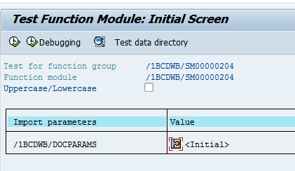

13) Click on Print preview

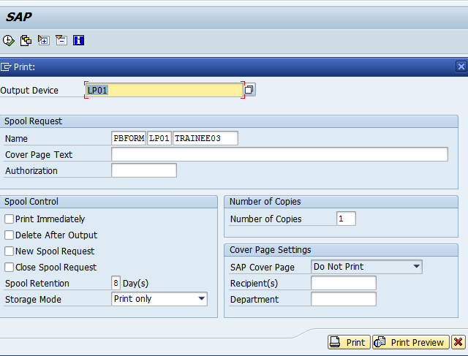

14) Expected output is as follows.

